**WEEK 5**

**Microservices with Spring Boot 3 and Spring Cloud**

**Creating Microservices for account and loan:**

**Create directories:**

* D:\<employee_id>\microservices\

**Create account spring project in microservices folder:**

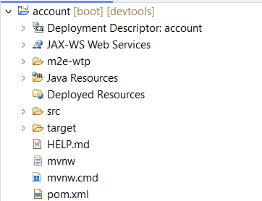

**Build the project:**

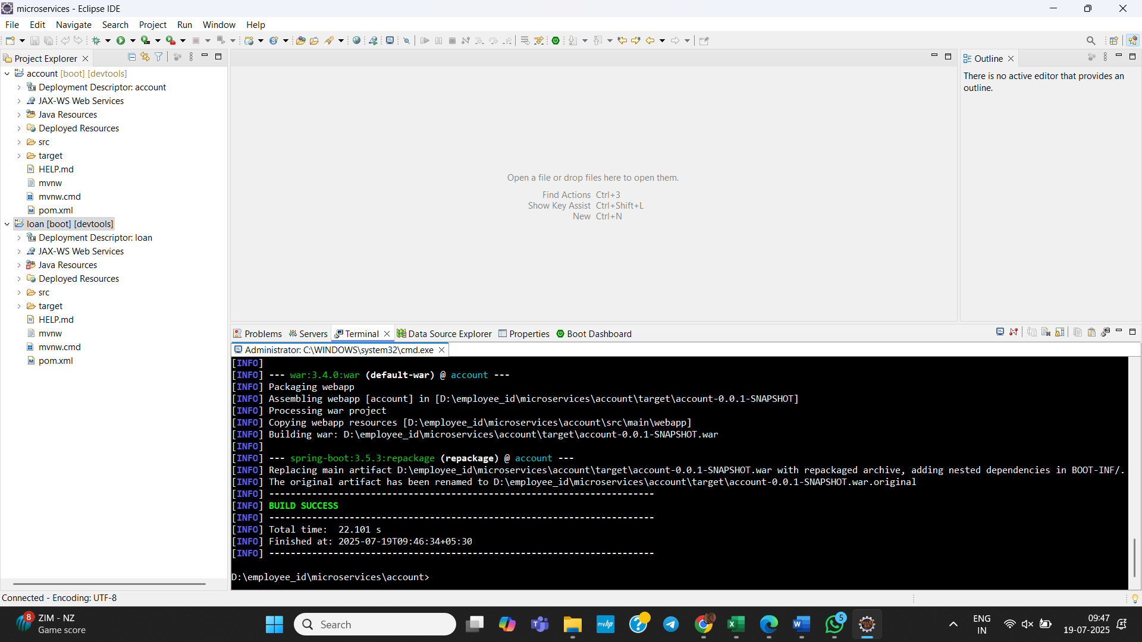

**Create AccountController.java in com.cognizant.account.controller package:**

**package** com.cognizant.account.controller;

**import** java.util.Map;

**import** org.springframework.web.bind.annotation.*;

**import** java.util.HashMap;

@RestController

@RequestMapping("/accounts")

**public** **class** AccountController {

@GetMapping("/{number}")

**public** Map<String, Object> getAccount(@PathVariable String number) {

Map<String, Object> response = **new** HashMap<>();

response.put("number", number);

response.put("type", "savings");

response.put("balance", 234343);

**return** response;

}

}

**Output:**

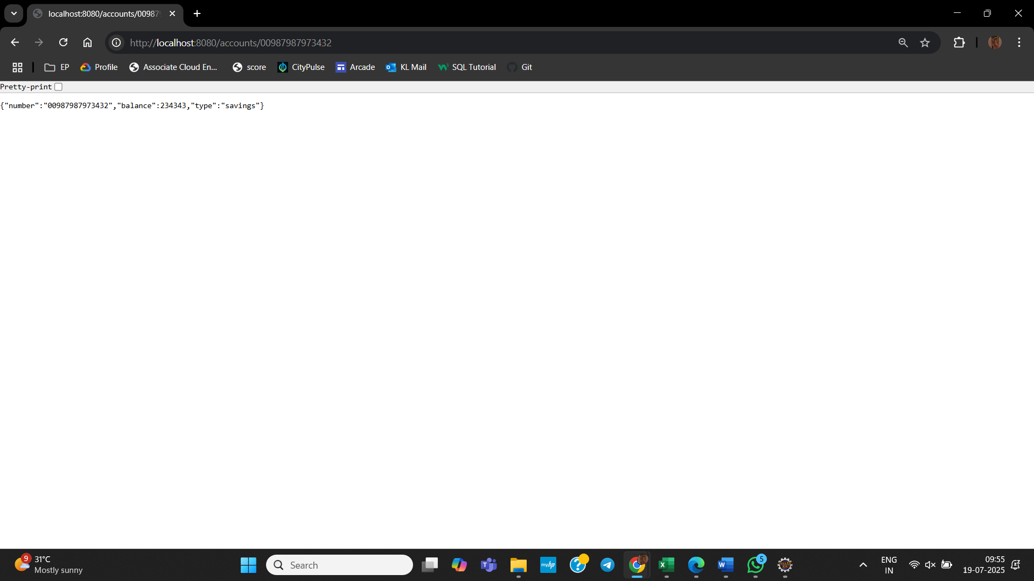

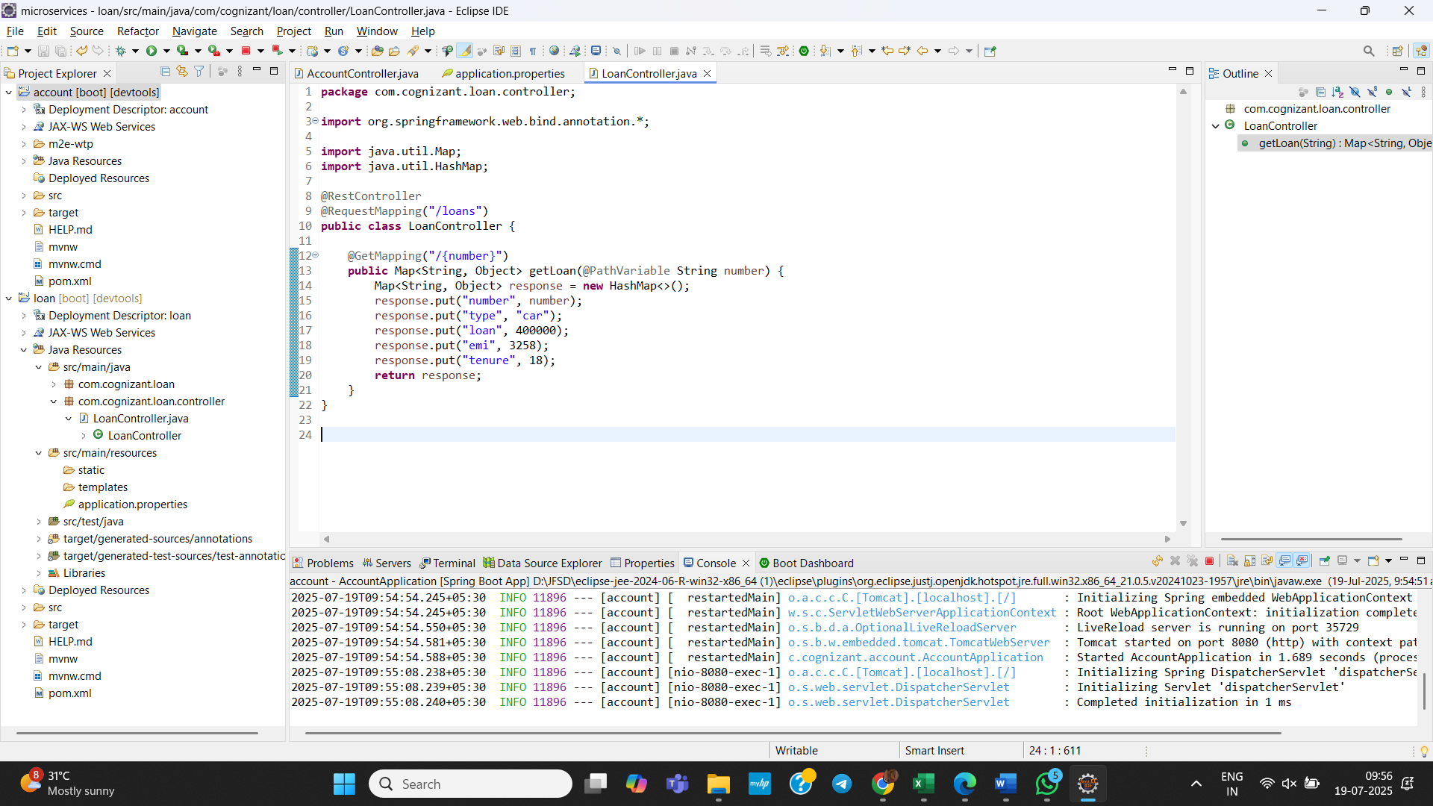

**Create loan spring project in microservices folder:**

**Change port to 8081 in application.properties using:**

server.port=8081

**Create LoanController.java in com.cognizant.loan.controller package:**

**package** com.cognizant.loan.controller;

**import** org.springframework.web.bind.annotation.*;

**import** java.util.Map;

**import** java.util.HashMap;

@RestController

@RequestMapping("/loans")

**public** **class** LoanController {

@GetMapping("/{number}")

**public** Map<String, Object> getLoan(@PathVariable String number) {

Map<String, Object> response = **new** HashMap<>();

response.put("number", number);

response.put("type", "car");

response.put("loan", 400000);

response.put("emi", 3258);

response.put("tenure", 18);

**return** response;

}

}

**Output:**

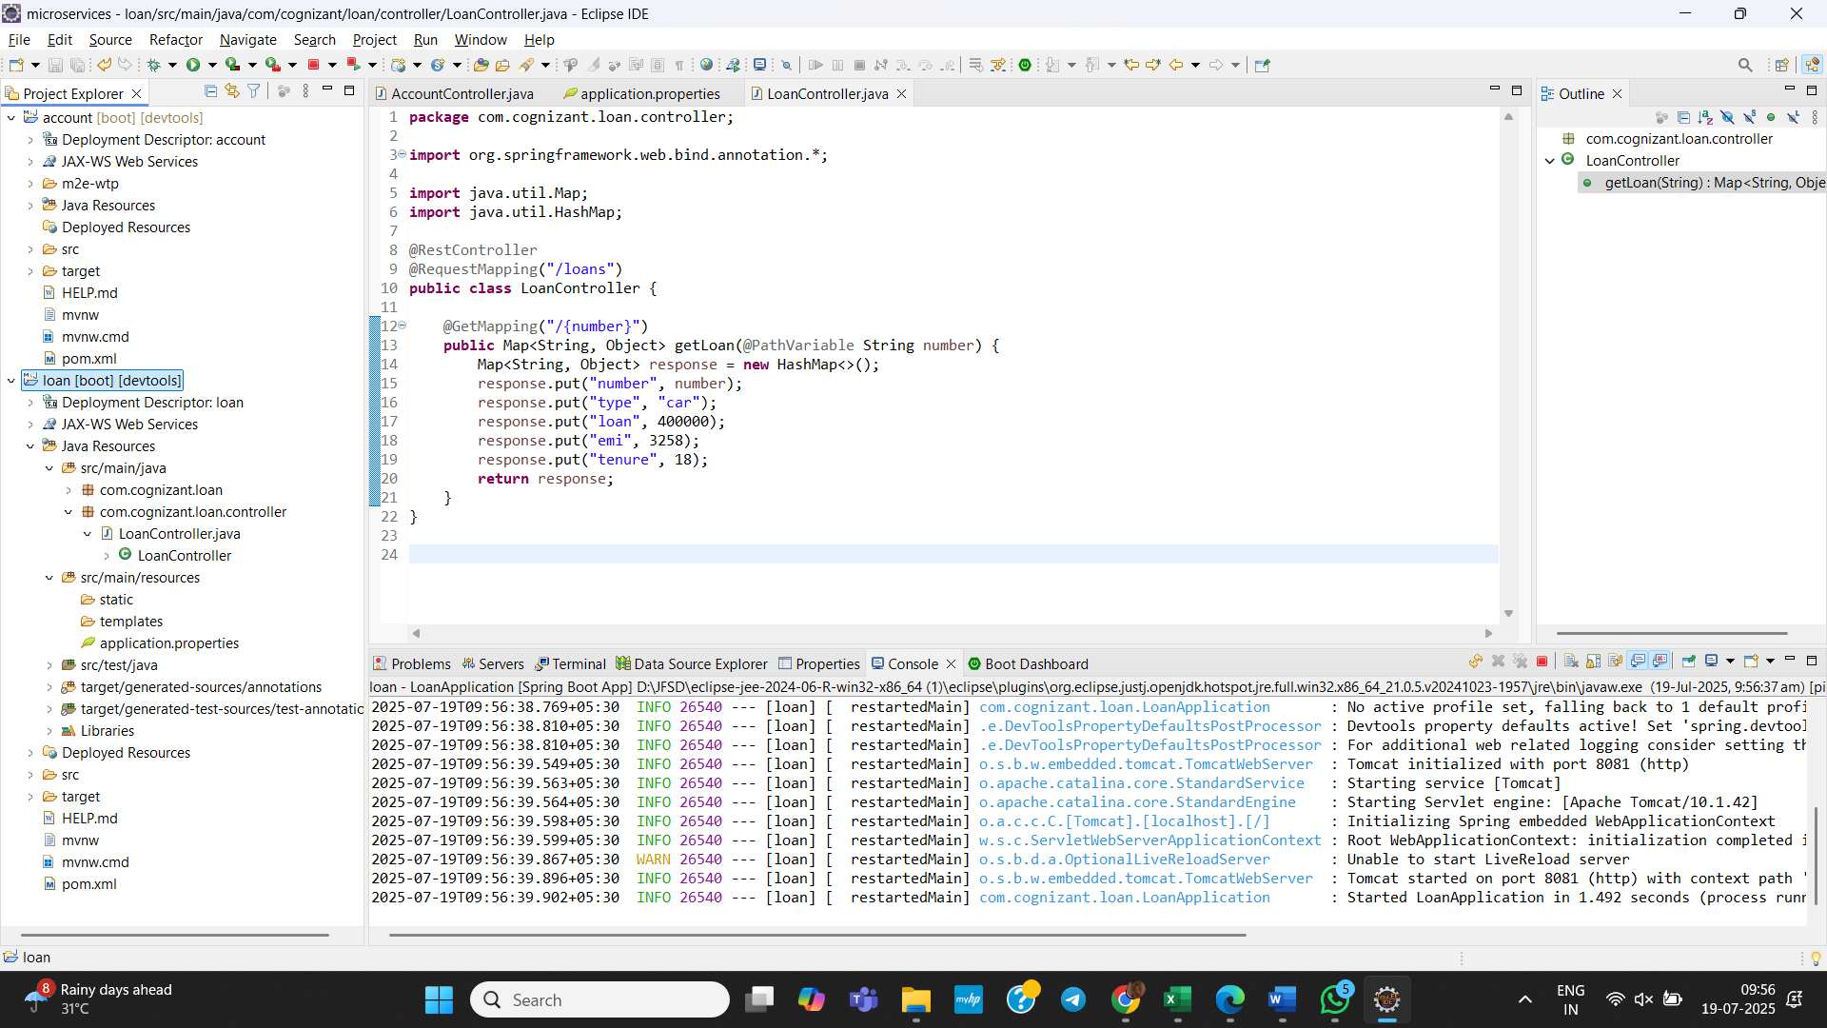 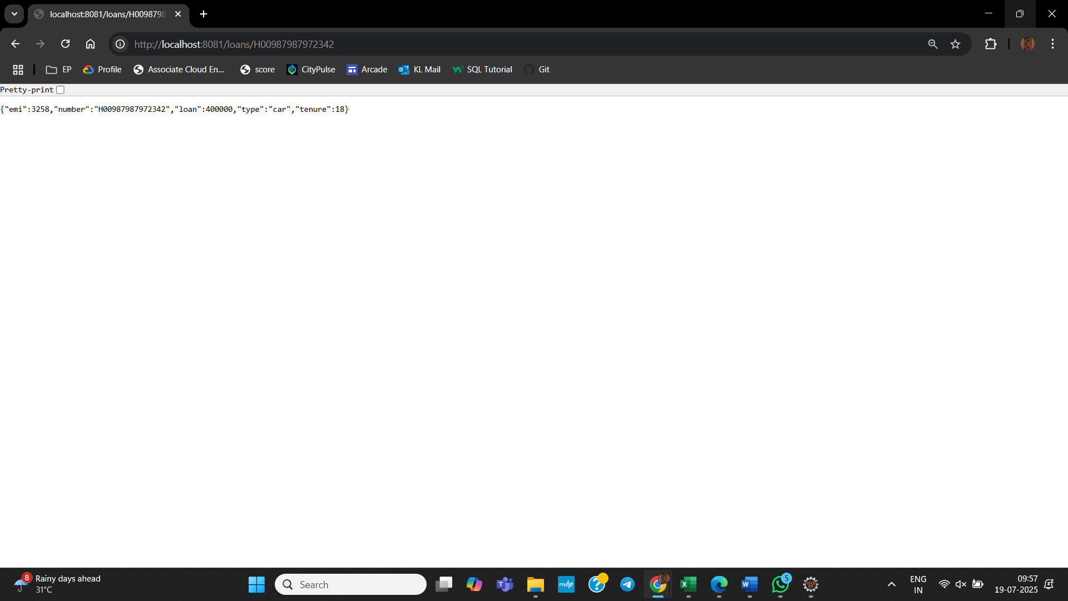

**Now we have two microservices running on different ports:**

